

Name: Anwesha Madavi PRN: 25070122043 Subject: Programming with Java
Batch: 2025-2029

ASSIGNMENT VI

TITLE: Implement a Java program to demonstrate inheritance and interfaces using suitable
real-world examples.

Problem Statement
Implement a Java program to demonstrate inheritance and interfaces using suitable real-world examples.

Learning Objectives
To implement inheritance and interfaces for achieving code reusability and abstraction.

Theory
Inheritance and interfaces are important concepts in Java that help in creating organized and reusable code. Inheritance allows one class to use the properties and methods of another class, which reduces code repetition and improves efficiency. Java supports inheritance using the extends keyword. Interfaces provide a way to define a set of rules or methods that a class must implement, allowing abstraction and supporting multiple inheritance of type. Together, inheritance and interfaces make programs more flexible, maintainable, and help achieve polymorphism, which is a key feature of object-oriented programming.

Exercise
1.Create a Shape application where Circle and Rectangle inherit from Shape and calculate area.

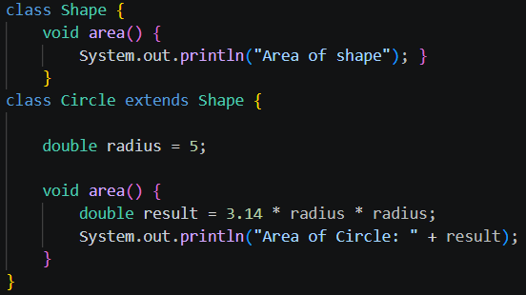
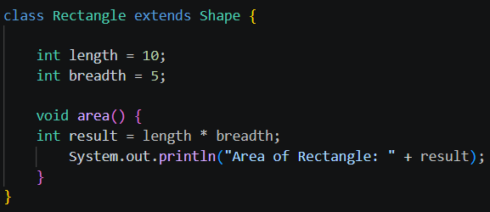
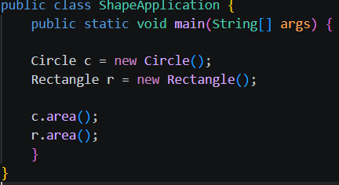
Outcome:


2.Develop an E-Commerce Product System where electronic, clothing, and grocery products
inherit common properties and implement product interfaces.
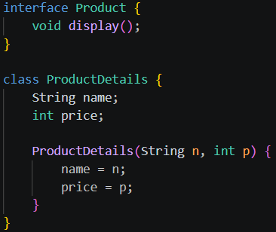
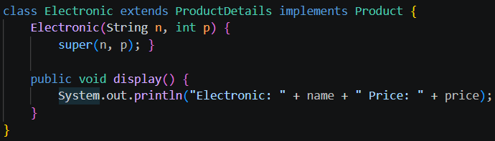
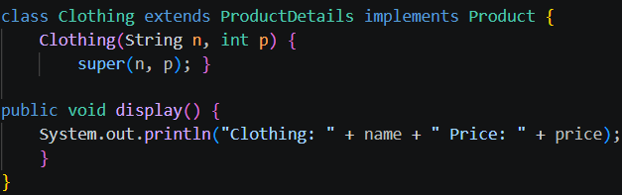
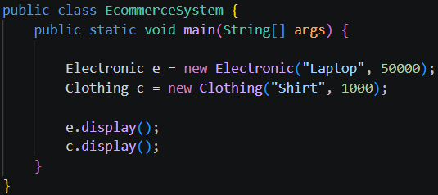

Outcome

Conclusion
This program shows how inheritance and interfaces can be used to create an organized e-commerce system. Common product details are shared through the parent class, while different products implement their own display methods. This makes the code simple, reusable, and easier to manage.

